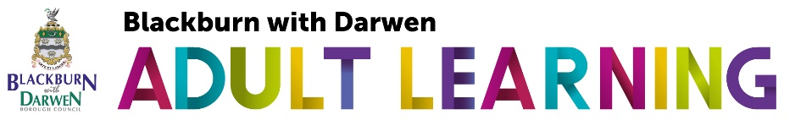
Lesson Plan 2020-2021

Course Title:
Tutor: |  | Venue:
Lesson Number: | Date: |  | Time:

Aim/intent of the programme:

Aim(s) of the lesson:

Learning Objectives for the Lesson (have these visible throughout lesson)

Health & Safety (List any potential Health & Safety Risks in the lesson and what actions will be taken to minimise risk):
Equality and Diversity (include details below and in the learner/tutor activity columns):
Planned Maths/English & ICT skills (include details below and in the learner/tutor activity columns):
Planning for individualised learning (differentiation);

Time | Topic | Learner Activity | Tutor Activity | Learning Objectives | Resources (including min 10% e learning) | Method of assessment | How is assessment recorded?

Tutor evaluation of lesson – this reflection will help you to identify changes and plan for future lessons:
What went well? What didn’t go so well?
If you had any late-comers how did you deal with this?
Which resources were the most effective and why?
Which resources were the least effective and how would you change them for future lessons?
Which activities did not run to the anticipated timings and how would you resolve this in future lessons?
Which (if any) of the activities were unsuitable for the lesson or group? What could you try next time?
What changes would you make for future lessons?

