



My Learning Diary

Name………………………………………………………

Course name………………………………………….

Course Aim(s) (**SP1)**

**………………………………………………………………………………**

Tutor:

Tick the picture which shows the best way for you to learn new things. You can tick more than one or add your own ideas.

I learn best by-

 

Listening Watching

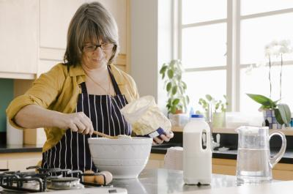 

Doing things Reading

My ideas for how I can learn new things-

…………………………………………………………………………………………………………………………………………………………………………………………………..

**How confident do you feel about learning new things?** (SP2)

**1. Very confident!**



**2. OK**



**3. Not very confident**



**At the end of the course we will ask you to answer this question again.**

On this course do you think that you will need help (support) with anything? (SP2)

Yes No

How can the tutor and support workers help you?

…………………………………………………………………………………………………………………………………………………………………………………………………..

…………………………………………………………………………………………………

…………………………………………………………………………………………………

…………………………………………………………………………………………………

**My Learning Diary** - use with group objectives (attached). (SP3/4)

Session 1

My favourite activity today was-

…………………………………………………………………………………………………………

One thing that I learnt was-

……………………………………………………………………………………………………………

I need to get better at-

……………………………………………………………………………………………………………

The goal I have set myself is-

……………………………………………………………………………………………………………

Tutor comment-

**My Learning Diary** - use with group objectives (attached). (SP3/4)

Session 2

My favourite activity today was-

…………………………………………………………………………………………………………

One thing that I learnt was-

……………………………………………………………………………………………………………

I need to get better at-

……………………………………………………………………………………………………………

The goal I have set myself is-

……………………………………………………………………………………………………………

Tutor comment-

**My Learning Diary** - use with group objectives (attached). (SP3/4)

Session 3

My favourite activity today was-

…………………………………………………………………………………………………………

One thing that I learnt was-

……………………………………………………………………………………………………………

I need to get better at-

……………………………………………………………………………………………………………

The goal I have set myself is-

……………………………………………………………………………………………………………

Tutor comment-

**My Learning Diary** - use with group objectives (attached). (SP3/4)

Session 4

My favourite activity today was-

…………………………………………………………………………………………………………

One thing that I learnt was-

……………………………………………………………………………………………………………

I need to get better at-

……………………………………………………………………………………………………………

The goal I have set myself is-

……………………………………………………………………………………………………………

Tutor comment-

**End of course review** (SP5)

**How confident do you feel now about learning new things?**

**1. Very confident!**



**2. OK**



**3. Not very confident**



**Learning Objectives**

How many Learning Objectives were selected? ....................

How many Learning Objectives were achieved? ...................

**Confidence Rating**

Beginning of course 1 2 3

End of course 1 2 3

Please attach the paperwork for the relevant group learning objectives from the individual sessions.

My next step is - (SP6)

………………………………………………………………………………………………………………………………………………………………………………………………………………………………………………………………………………………………………

Tutor signature …………………………………………………………….

Learner signature …………………………………………………………