Online Learning Policy

Introduction
Blackburn with Darwen Adult Learning works closely with adults, some of whom are vulnerable. We believe that every adult has the right to access high quality teaching and learning whether online or in a classroom setting.
This policy sets out the expectations of staff, learners and any other relevant person relating to online learning. It applies to all learners across our provision and all staff are expected to read, understand and adhere to this policy and related procedures.

Context
As part of the Adult Services and Prevention Department within the council, the Adult Learning Service has a responsibility to ensure the safety of our learners in class and online. This policy sets out how learners and staff are expected to conduct high quality teaching and learning in a safe online platform.
Blackburn with Darwen Adult Learning recognises its responsibilities in providing staff and learners the necessary information and guidance to ensure that people remain and feel safe at all times.

Purpose of the Policy
The purpose of this policy is to:
- Clarify the roles, responsibilities and expectations of Adult Learning staff in relation to online learning.
- Clarify the responsibilities and expectations of learners, and others, in relation to online learning.

Policy Details
Location
Learners and staff should consider where they are located when they join virtual classrooms. Where possible in the interest of safeguarding, individuals should not join virtual sessions from their bedroom or with personal details in sight. This is a learning environment so learners and tutors should ensure they are able to participate with minimal interruption as in a real classroom.

Dress code
Learners and staff should dress as they would to attend classroom based learning, therefore nightwear is not appropriate attire and should not be worn to any live online learning session.

Language
Learners and staff should use appropriate language and agree this is the class ground rules. Both groups should refrain from the use of swearing, racial, discriminatory or derogative language.
Behaviour
Learners and staff should treat each other with respect, tolerance and patience when in the online learning environment. Learners should demonstrate active participation in online learning, discussion and chat as required.

Attendance & Punctuality
This is covered in the Adult Learning Service’s ‘Managing Learner Attendance Policy’, which should be adhered to for online learning purposes.
Late arrivals will not be accepted into the live online learning environment more than 10 minutes after the start time.

Safeguarding Online
Learners and tutors should not share personal details online within the group. Learners should refrain from sharing of any personal information with other learners and any communication should be via the tutor. Learners are able to communicate with each other via the platform which the tutor will also have sight of and be able to monitor any inappropriate comments, behaviour or sharing of information including images.
Tutors should follow the Adult Learning Service Safeguarding Policy if they are worried about someone or something they witness in an online platform. Learners are able to report to their tutor via email if they have any concerns or by contacting the centre.
Tutors should report any illegal content that might be shared online, both internally within our organisation following our Safeguarding Policy and externally to www.reportharmfulcontent.com
Users can be removed from sessions by the tutor if they sharing inappropriate material in a virtual break-out session.
Managers and SDO’s can enter live sessions for quality monitoring and safety purposes.

Health and Safety
In addition to the service Health and Safety Policy tutors need to ensure that they carryout safe working practices in all teaching environments including online lessons from their home.

GDPR
Personal information will be collected using an online enrolment system or via telephone enrolment. Data will be stored in line with GDPR guidance and policy.
Learners will be contacted via email, text message or telephone to confirm attendance.

Course Guidance
Marketing
All courses will be publicised using Eventbrite where learners can book on to any free session, marketing will include information that the session is free to residents of Blackburn with Darwen aged 19+. Once sessions are full, a waiting list will be collected via Eventbrite. The monitoring of bookings on Eventbrite will be monitored by the administration team. Learner details will be shared with the tutor before the event, the link to the online class to be shared.

Enrolment
Learners will enrol via Eventbrite or telephone, they will receive a confirmation email with details regarding the process of accessing the online learning platform. Learners will be contacted prior to their session to ensure they have access to digital devices and able to access course materials. NCS, admin team and SDO’s will support the contacting of learners. Information regarding learners accessibility will be shared with the tutor prior to the session.

The enrolment list will be downloaded and shared with the SDO prior to the session to ensure they have sufficient time to distribute the link to the session to learners. SDO’s will contact learners using the BCC function on email to ensure that learner details are not shared, in line with GDPR.

Administration team to contact learners to complete outstanding enrolment information and pre course triage.

Quality
As in any classroom situation the key principles of teaching, learning and assessment apply, this includes the RARPA process. High quality TLA should be planned and delivered in all classroom situations.
Tutor should present information and/or demonstrate skills clearly, promoting appropriate consideration of the subject matter being taught.
All learners will be supported to join online learning platforms and participate in an induction process to ensure connectivity and accessibility. Guidance notes will be provided to ensure learners are able to access the online learning platform prior to the course/session. Sessions will be between 45-60 minutes to reduce screen time.

Presentation
All presentations are to be produced using the BwD template to ensure consistency of branding and a professional appearance.
Font style to be set at Calibri (body), at least size 24, but with varying sizes, depending on the amount of text being used. Ensure that when changing the colour of text that it is visible to all.
Photo images to be used in the majority of circumstances to ensure good quality visuals. Ensure these are not stretched, distorted or blurred when inserting.
Have information appear in segments to ensure learners are not overwhelmed by the information appearing all at once.
Presentations to be check for spelling, grammatical and punctuation errors.
When using sound clips and inserts ensure the sound quality is audible.
Links to websites/resources/quizzes etc are to be current, functional and provided in a shortened form using bitly.com and/or QR codes.

Pre-recoded Videos and Live Sessions
These are to be produced to a professional standard within an appropriate environment, checking what is seen on the screen by learners.
All videos to start with, “Welcome to (insert course title) at Blackburn with Darwen Adult Learning, my name is (insert name) and I will be your tutor for this session. A picture of the tutor should be visible on the introductory slide.
Learners’ behaviour, attitudes and comments online should be monitored in the same way as they would in any classroom situation. Using the tools available within the online learning platform it is possible to mute, turn off video or remove learners who are displaying inappropriate behaviour.
Some learners may be late so having a five-minute “do now” task or retrieval quiz on a PowerPoint slide as they join gives you a few minutes to gather your thoughts and greet everyone as they arrive.
Remind learners to stay muted and only use the chat for responding to tasks will help to reduce the number of potential issues with behaviour.
At the start of any session, tutors need to reiterate Health and Safety, ground rules, etiquette and key functions within the live session.
Learners to be informed that the sessions will be recorded, where appropriate, and stored by BwD Adult Learning in accordance with GDPR.
Pre-recorded videos will be uploaded to the website and shared on social media.
Live sessions will be produced using MS Teams. Learners will be able to enrol and be sent a link to the ‘meeting’ and join the session remotely.
Tutors need to be present in the session prior to any learners and ensure all learners have left the session before leaving the 'classroom’ themselves.

Assessment
The checking of learners’ understanding should be carried out systematically to identify and address misunderstandings and provide clear, direct feedback.
Tutors should use assessment to establish learners’ knowledge, to evaluate the application of skills and to check understanding and inform teaching.
Once you have taught the material, you must check that all learners understand, using a couple of the following options: unmuting students and using cold call; using a poll in the chat feature; setting a quick quiz; or using the whiteboard facility in MS Teams. Whatever method you use to check for understanding, ensure that the data you gather informs your next steps.

Feedback
Feedback to learners will be on an individual basis and will differ for, and be appropriate to, each learner. Verbal feedback can be given immediately or as a follow up tutorial call. Additional methods can be used including email, online chat, text messaging and video feedback.
Tutors to carry out tutorials with learners on longer courses in order to capture learners’ progress and record learning and achievement. Learners to be able to share their feedback and request support around their online learning experience.
Ensure you address the learners by name so that they know they are being spoken to.

Teaching Methods
The study delivered will be fit for purpose using the correct e-learning method. Tutors will fully explain the online materials/resources and the standard of work expected.
Tutors will differentiate and offer a range of materials to support all learning methods and adapt where possible.
If courses require printed materials, learners should expect to receive those 2 days prior to the session. Copies can be collected or posted by arrangement – call 01254 507720 if this is required. Collection will be available from Bank Top Neighbourhood Learning Centre or Audley Neighbourhood Learning Centre Mon-Thurs, 8am-5pm and Fri, 8am-4pm.

Support
Learning Support is available on request. This should be made prior to the start of the course by contacting the service. Alternatively, learners should make tutors aware of additional needs at enrolment. Action will then be taken to support learners in additional sessions, where appropriate.
Learning support workers to be present in all Positive Minds courses with the option for learners to join a break out area in a parallel room for support purposes.
Where learning support is required, learners will be able to access course materials at their own pace with a learning support tutor at an agreed time.
Working with the National Careers Service allows all learners to access impartial information advice and guidance at stage of the learning process. Tutors can make referrals or contact NCS on behalf of learners.
Digital support is available to all learners by contacting ICT/Employability Support Service within the service on 01254 507720.

Terminology
E-learning - learning utilizing electronic technologies to access learning outside of a traditional classroom.
Distance learning - a method of studying where tutors conduct lessons online without the learners needing to attend a building.
Blended learning - a mix of learners learning via electronic and online media as well as traditional face-to-face teaching.
Tutor-led learning – lessons which are led by tutors either online or in a traditional classroom
Web-based materials – additional online materials used to support teaching, learning or assessment which are produced by other organisations (e.g www.learnmyway.com)

Appendix 1

Join a Microsoft Team Meeting without a Team Account

You can join a Teams meeting from any device, whether or not you have a Teams account. If you do not have an account, follow these steps to join as a guest.

Desktop

- Go to the meeting invite or agenda and click Join Microsoft Teams Meeting.

- That will open a web page, where you will see two choices:

Download the Windows app and Join on the web instead.

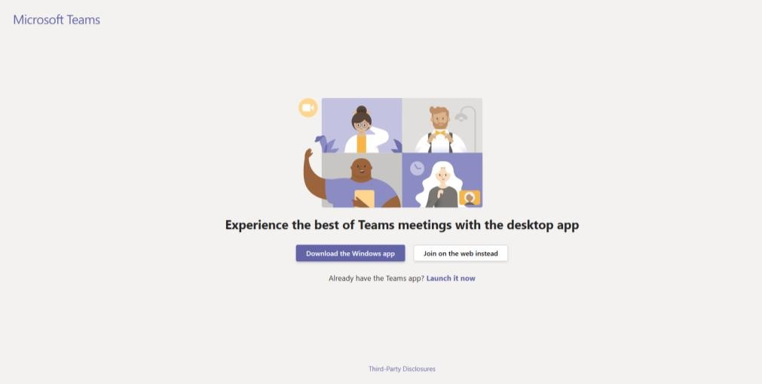

If you join on the web, you can use either Microsoft Edge or Google Chrome. Your browser will then ask you to use your webcam and microphone, so be sure to accept both. This ensures you’ll be seen and heard during the meeting.

- Enter your name and choose your audio and video settings.
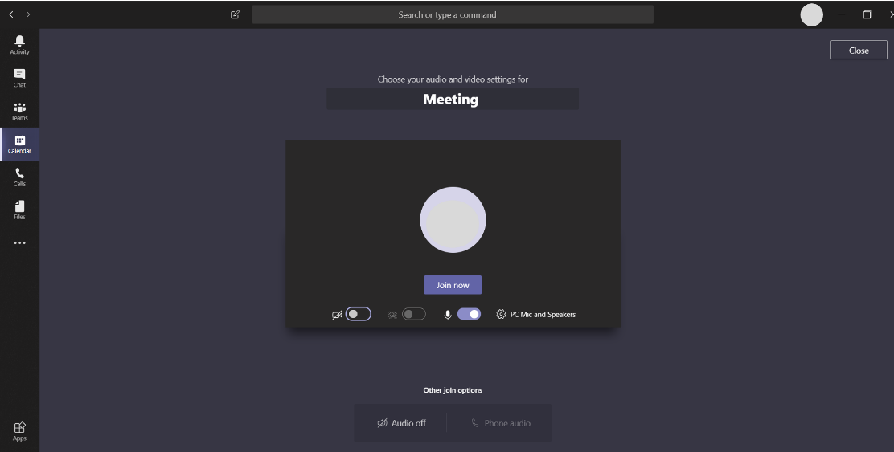

- When you are ready, click Join now.
- This will bring you into the meeting lobby. The meeting organiser will be notified that you are there and will admit you.
Mobile

- Go to the meeting invite or agenda and select Join Microsoft Teams Meeting.
- If you do not already have the Teams mobile app, you will be taken to your app store to download it.

- Download the app and open it right from the app store page.

Teams will ask if it is okay to use your mic. Be sure to allow it so others in the meeting will be able to hear you.

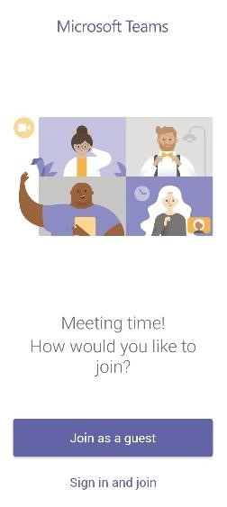
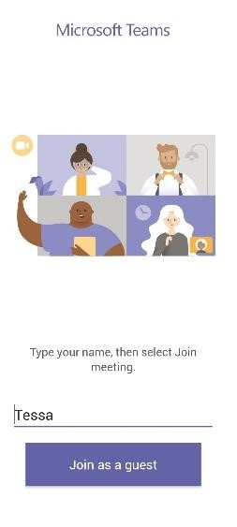
- Next, you will be given 5. Type your name and tap two options for joining Join meeting.
your meeting: Join as a guest or Sign in and
join. Choose Join as a
guest.

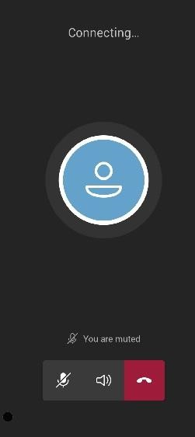
- To turn your video or mic on or off during the meeting, tap on the centre of your screen to show the meeting controls. Tap again to hide them.

- This will bring you into the meeting lobby. The meeting organiser will be notified that you are there and will admit you.

