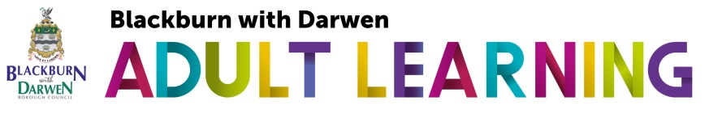  Short Course Learning Agreement 2020-21  (For courses of 10 hours duration or less)  Our short adult learning courses are funded by the Education & Skills Funding Agency (ESFA). These courses are usually free to our learners. To qualify for this funding we need to ensure that all learners are eligible and have a learning agreement.  Please read the information below:  ----------------------------------  We offer a wide range of adult learning. Every learner is important to us and we want you to enjoy your learning. To make the most of this short course we ask you to:  - Complete an enrolment form with your full and accurate details  - Complete a ‘Short Course ILP, Progress & Achievement Record’  - Behave in a way that ensures your safety and the safety of others  - Respect the needs of others and the ‘ground rules’ agreed at the start of the course  - Treat everyone with respect and courtesy  - Let the tutor know if you need any extra help or support  - Attend all sessions and be on time  - Tell us what you would like to do next  - Give feedback at the end of the course  Learning Agreement  - I agree to complete the short course documentation (or ask for help) to complete it accurately  - I agree to follow the ‘ground rules’ agreed with my tutor including health and safety rules  - I agree to respect the needs of others and treat people with respect and courtesy. |  | Comments, suggestions, compliments or complaints?  My comment/suggestion/compliment/complaint is:  Continue on a separate sheet if necessary  What would you like the council to do?  Please give us some information about yourself  Name: ________________________________________________________  Address: ______________________________________________________  ___________________________________ Postcode: __________________  Telephone no: __________________________________________________  Email: _________________________________________________________  Date: _________________________________________________________  Please place this form in a sealed envelope and send to :  MIS team  Blackburn with Darwen Borough Council  Adult Learning  M Floor, Town Hall  Blackburn  BB1 7DY

